

**Quizlet**

**Software Requirement Specification**

– Hanoi, February 2023 –

Record of changeS

|  |  |  |  |
| --- | --- | --- | --- |
| Date | A* M, D | In charge | Change Description |
| 13/Feb | A | PhuongNV | * Create UI of folder page * CRUD folder * CRUD study sets in folders * Modified database |
| 13/Feb | A | AnhTHV | * Create UI screen home page before login page * Create UI of class screen * CRUD class * CRUD folder in classes |
| 13/Feb | A | GiangNH | * Create UI of footer * Search by study set name * Answers of professors * Create UI of answers of professors |
| 13/Feb | M, A | VuBL | * Create login, register * CRUD study sets * Modified animation, UI * Share study sets |
| 13/Feb | M, A | HungBM | * Modified a verify, login and register * Modified filter * Create your library * Forgot password |

*A - Added M - Modified D - Deleted

**Table of Contents**

I. Overview 4

1. Introduction 4

2. System Functions 5

3. Entity Relationship Diagram 6

II. Functional Requirements 7

1. <<Feature Name 1>> 7

a. <<Function Name 1>> 7

b. <<Function Name 2>> 7

2. <<Feature Name 2>> 7

# I. Overview

## 1. Introduction

* The Quizlet Online Learning is a new software system that supports storage and management of courses. At the same time, you can refer to and study other people's folders and courses if you have permission from the owner. The system is expected to evolve over several releases, ultimately connecting to the Internet ordering services for several local schools to test and improve.

**2. System Functions**

#### a. Screen Flow

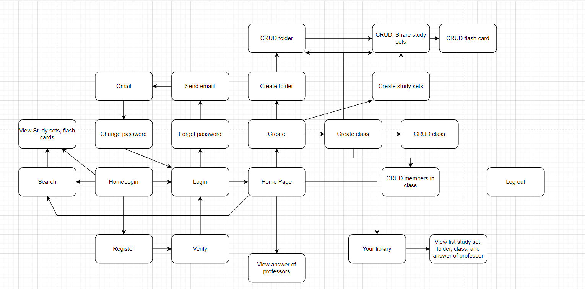

#### b. Screen Details

*[Provide the descriptions for the screens in the Screens Flow above]*

|  |  |  |  |
| --- | --- | --- | --- |
| **#** | **Feature** | **Screen** | **Description** |
| 1 | Login/ Register | Login/ Register | Create a form to login and register, user can register and login after verify email. |
| 2 | Study sets info | Study set | Show all info and all card in study sets |
| 3 | CRUD study set | Study set | Add, update, delete study set but study set must have 2 or more cards. |
| 4 | Search study set | Header | Search study sets by study set name or user name |
| 5 | Folder info | Folder | Show folder info and create a new folder and save it to database |
| 6 | Card info | Flash Cart | Show cards info |
| 7 | CRUD cards | Flash Cart | Add, Update, Delete cards |
| 8 | CRUD folder | Folder | Add, update, delete folder and add, delete study sets in folder |
| 9 | CRUD class | Class | Add, update, delete class and add, delete study set, folder, user in class |
| 10 | Reset password | Reset | Reset password by email if user forget password |
| 11 | Check mail | Check mail | Remind user check mail to change pass word |
| 12 | Change password | Change password | User input new password and confirm to change and return login |
| 13 | List study set | Study set | List study set |
| 14 | List class | Class set | List class |
| 15 | List folder | Folder set | List folder |
| 16 | Your library | Home | List study sets, folders, classes and answers of professors nearest |
| 17 | Verify | Verify | Verify code to active by checking email |

#### c. User Authorization

*[Provide the system roles authorization to the system features (down to screens, and event to the screen activities if applicable) in the table form as below – replace Role1, Role2,… with the specific system user role names]*

|  |  |  |
| --- | --- | --- |
| **Screen** | **User** | **Guest** |
| HomePage | X | X |
| Home | X |  |
| Login | X | X |
| Register | X | X |
| FlashCard | X | X |
| Search | X | X |
| Create Set | X |  |
| Verify | X |  |
| Folder | X |  |
| Update Set | X |  |
| Forget password | X | X |
| Check mail | X | X |
| Change password | X |  |
| Class | X |  |
| Class set | X |  |
|  |  |  |

In which:

* User role: do all function of page
* Guest role: only access to homepage, login/register, view cards and search study sets.

#### d. Non-Screen Functions

*[Provide the descriptions for the non-screen system functions, i.e batch/cron job, service, API, etc.]*

|  |  |  |  |
| --- | --- | --- | --- |
| **#** | **Feature** | **System Function** | **Description** |
| 1 | <<Feature Name>> | <<Function Name1>> | <<Function Name1 Description>> |
| 2 | … |  |  |

## 3. Entity Relationship Diagram

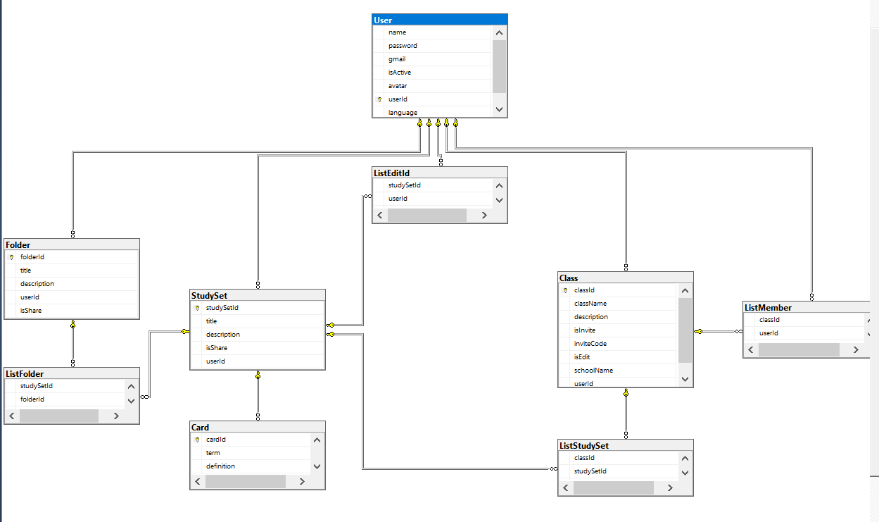

**Entities Description**

|  |  |  |
| --- | --- | --- |
| **#** | **Entity** | **Description** |
| 1 | User | All information of users |
| 2 | Card | All information of list cards |
| 3 | Study Set | All information of list study sets |
| 4 | Class | All information of list class |
| 5 | Folder | All information of list folder |
| 6 | List Folder | A class contain folders |
| 7 | List study set | A class contain study sets |
| 8 | List member | A class contain user |
| 9 | List edit id | A user has many study sets |

# II. Functional Requirements

**A. Before Login**

## 1. Homepage

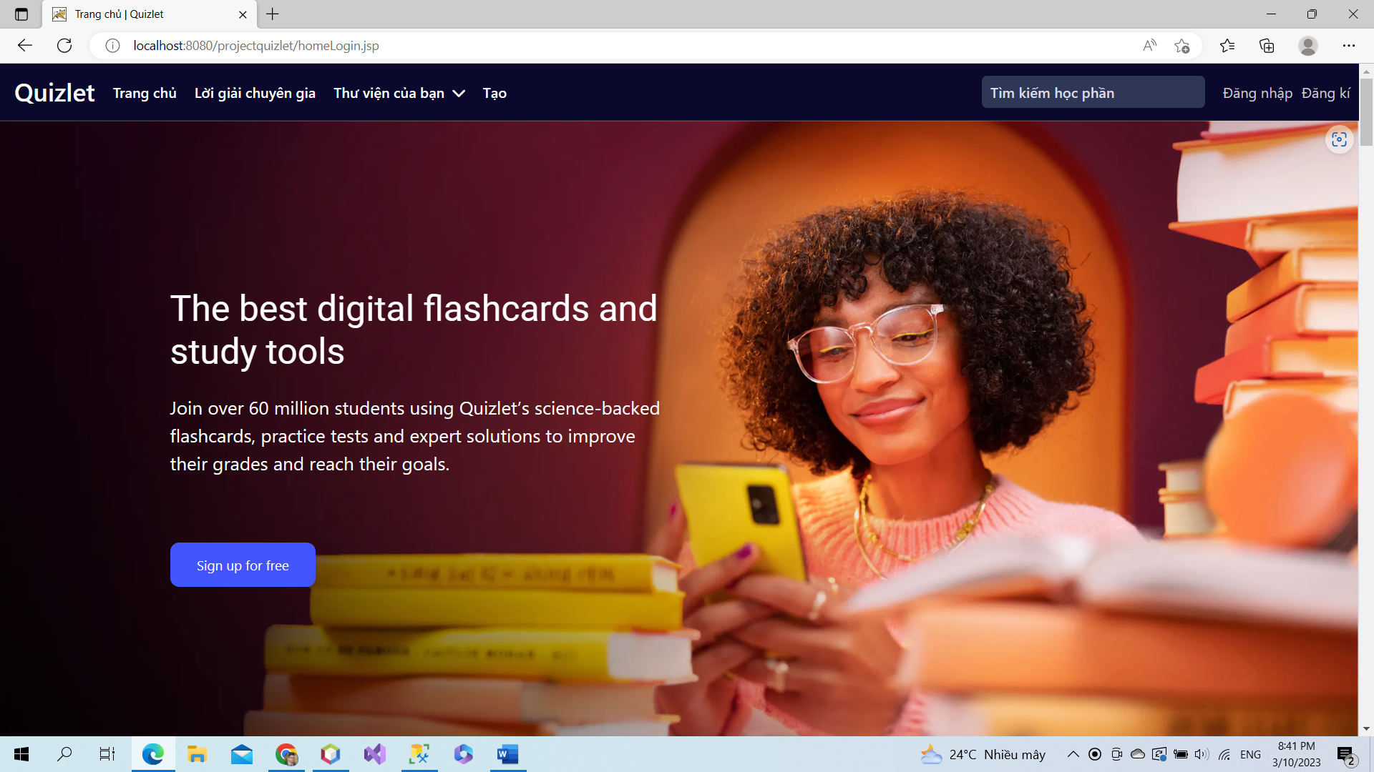

*This is home page before user login or register. Everybody can access this page.*

### 2. Search

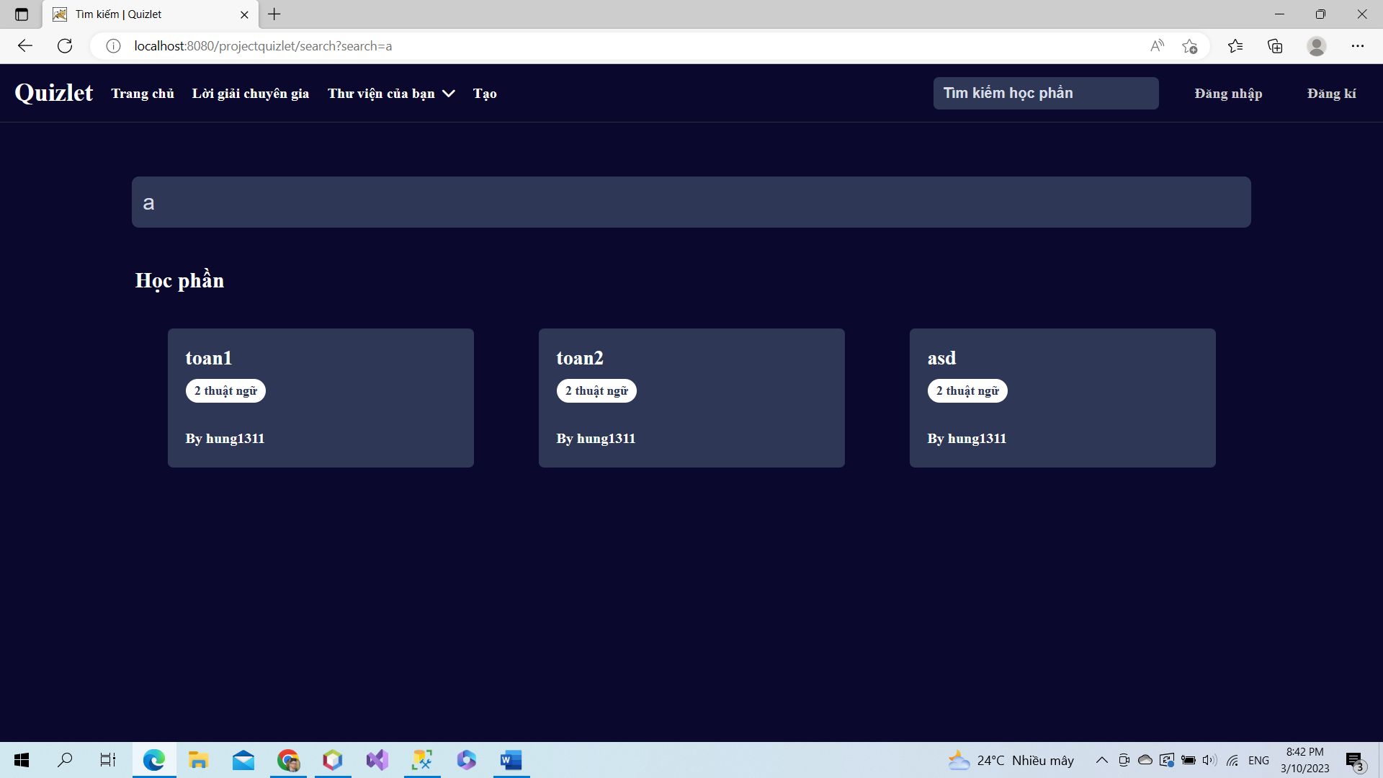

Everybody can search study set by name study set or user name.

### 3. View study set

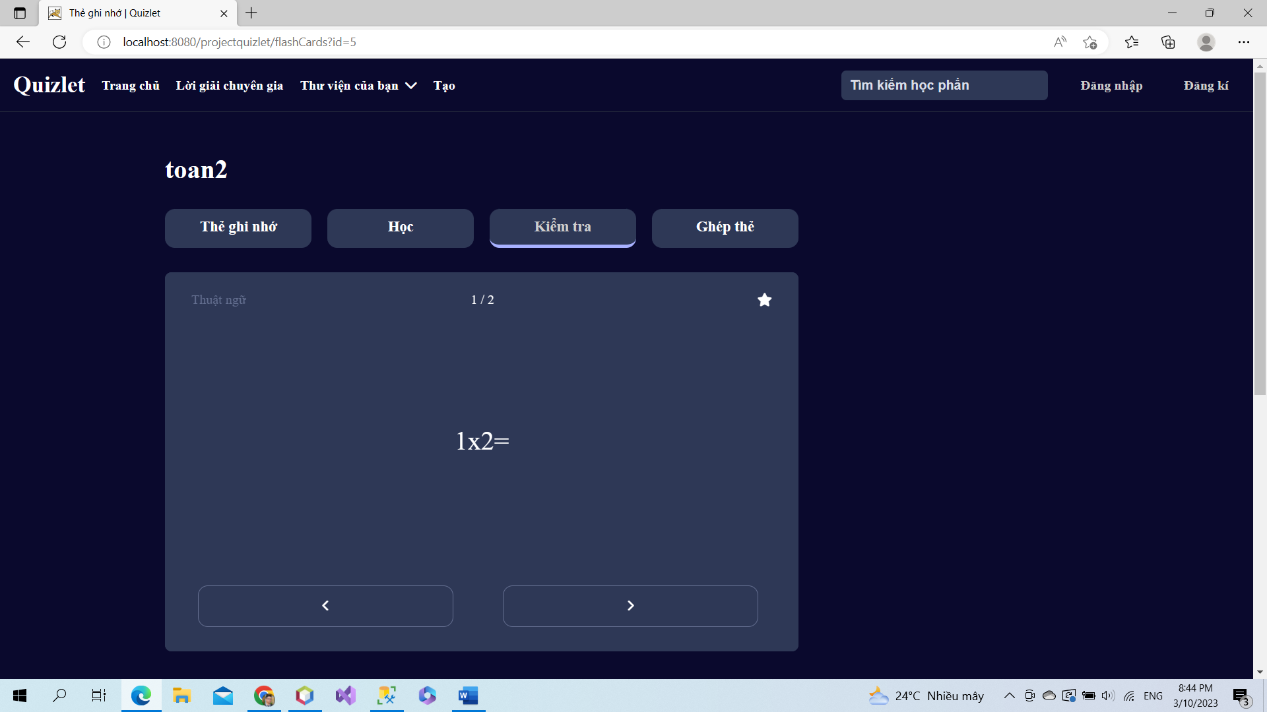

Everybody only can view study set and cards.

**B. Login**

## 1. Login

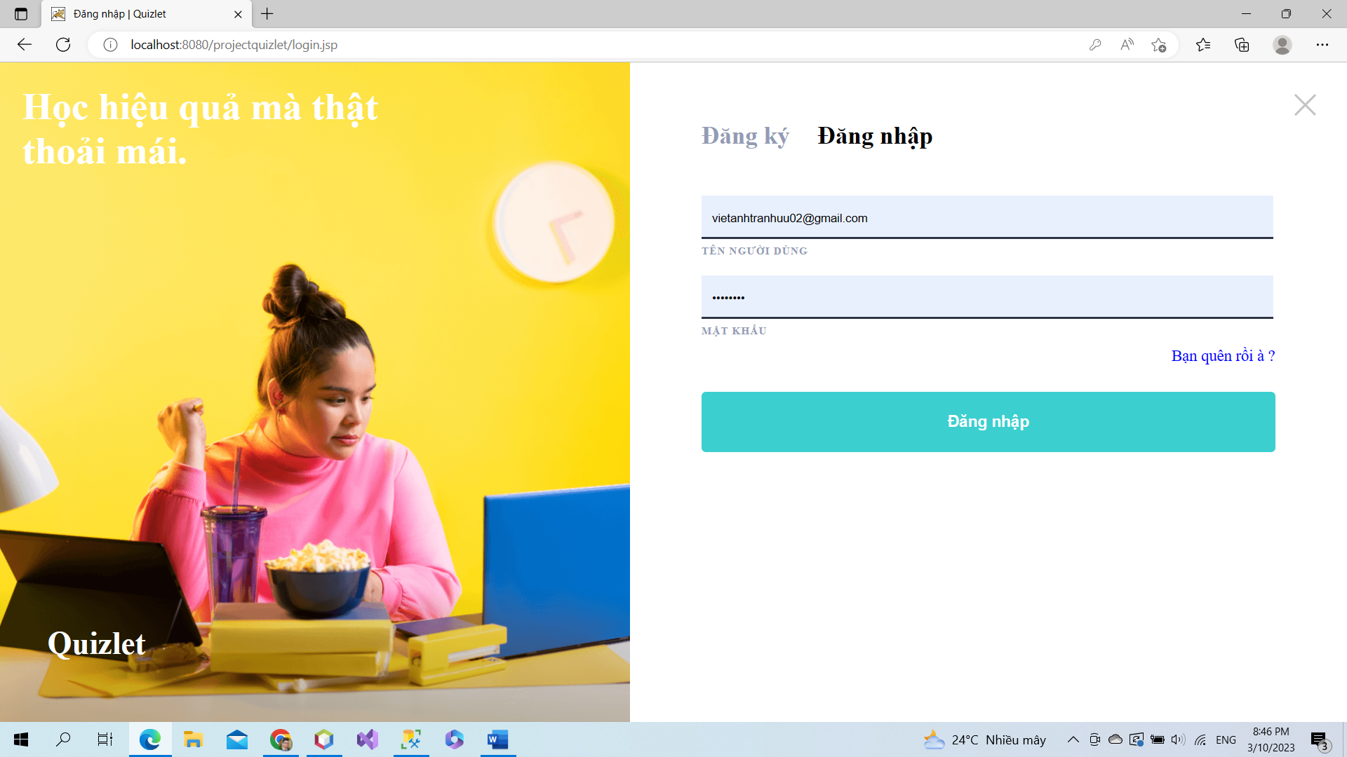

Everybody can login in this page.

## 2. Register

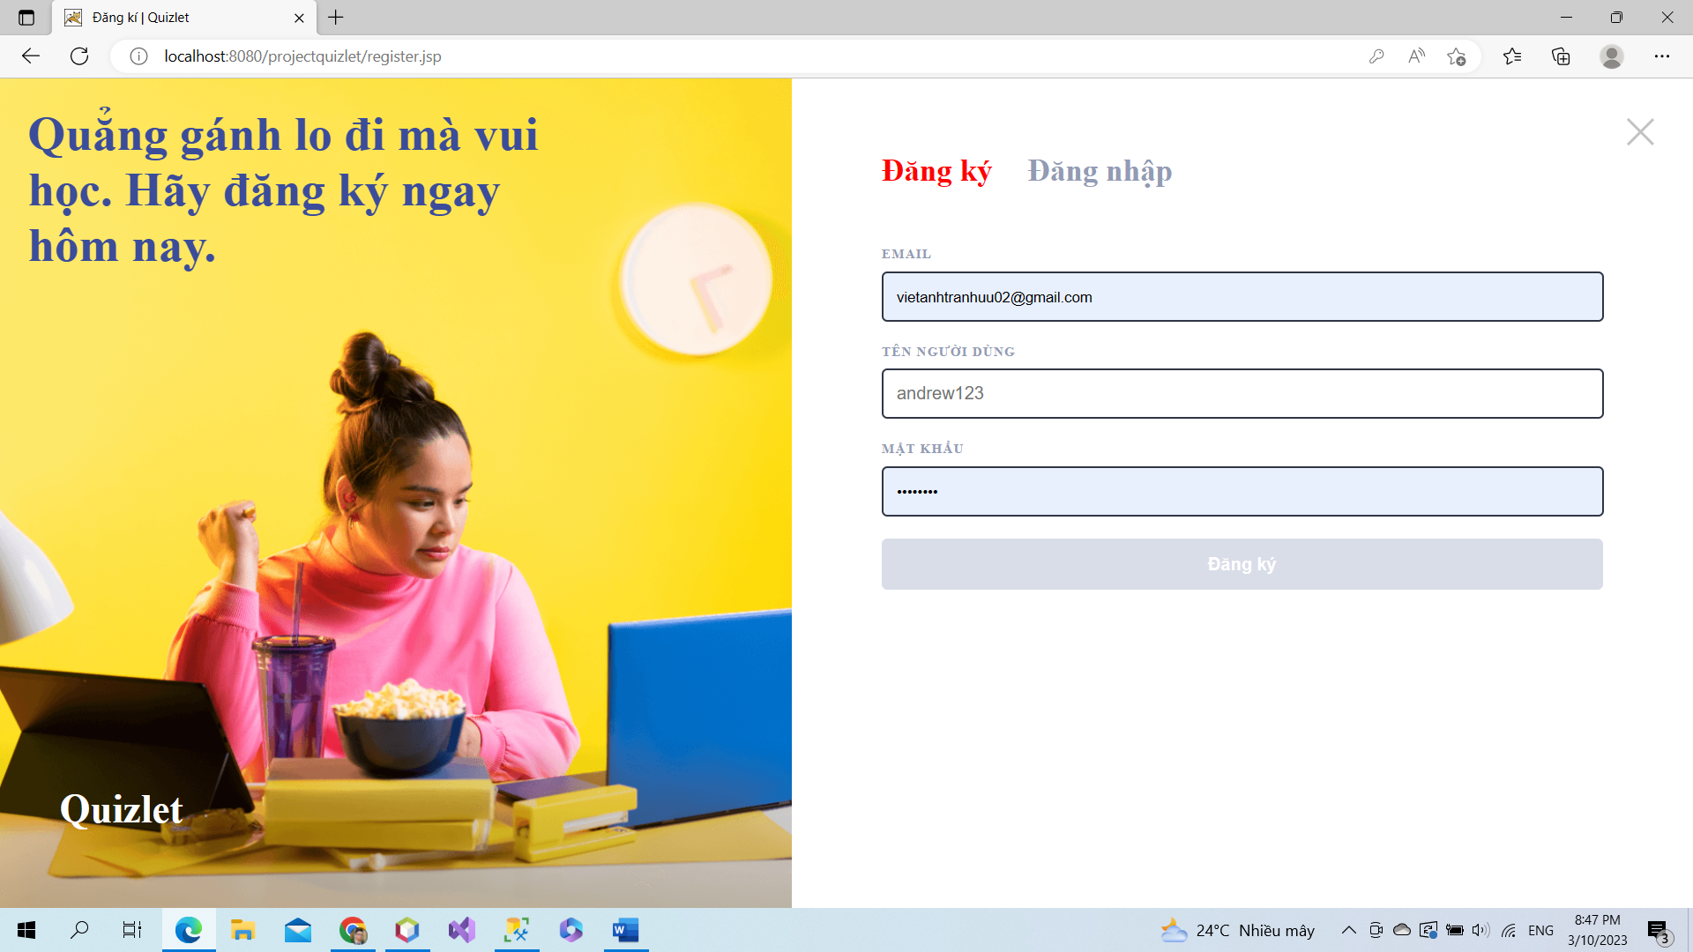

User register an account in here. User must use email, username and password.

## 3. Forgot password

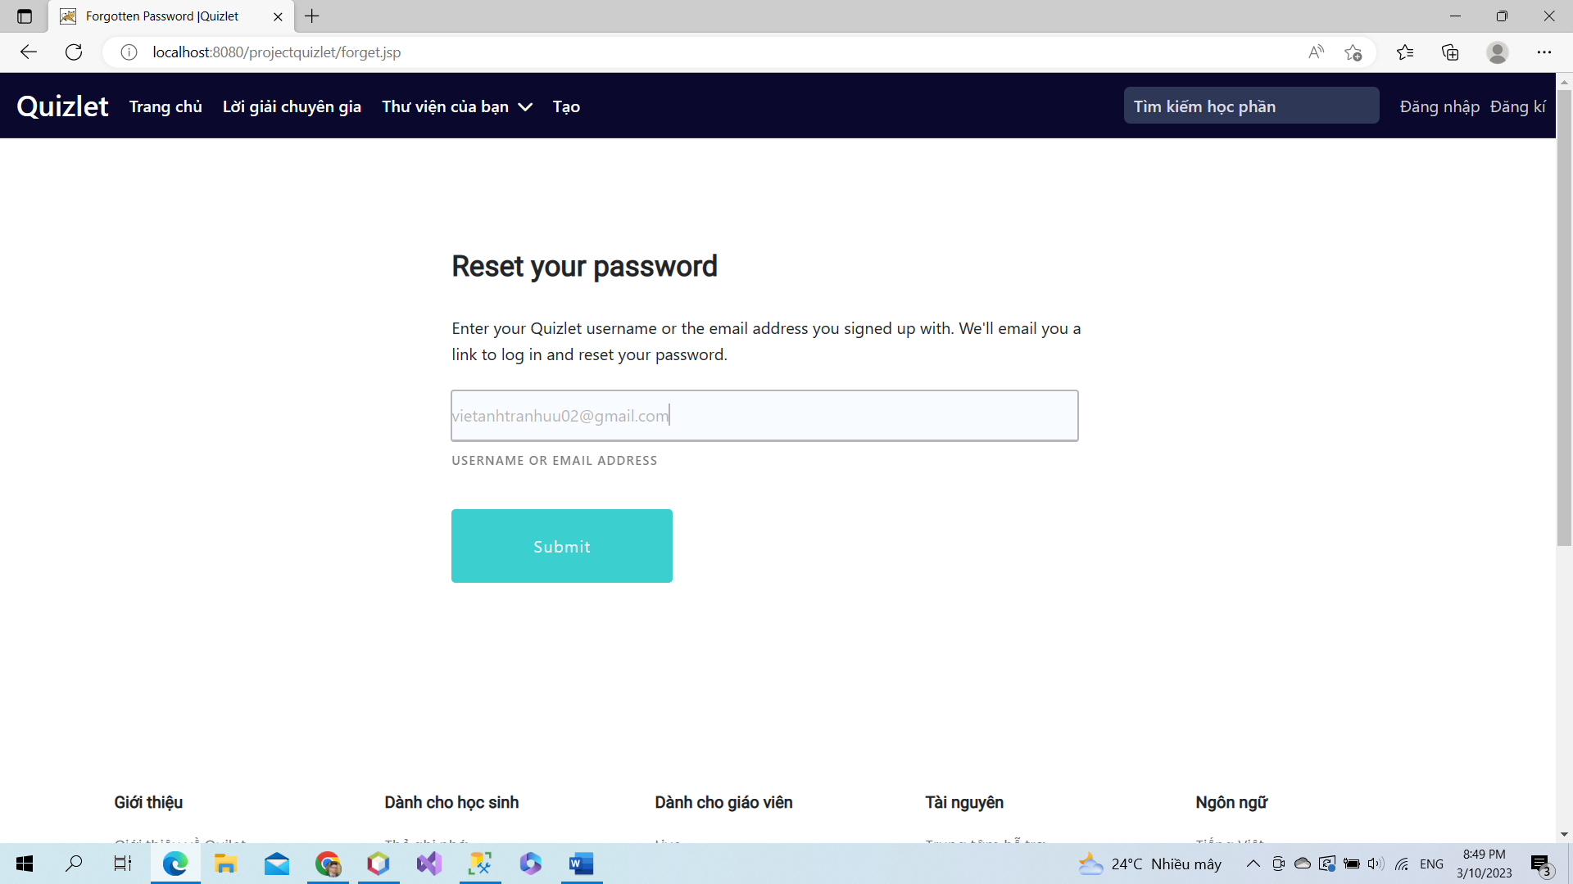

If users forget their password, they must use email to reset password.

## 4. Check mail

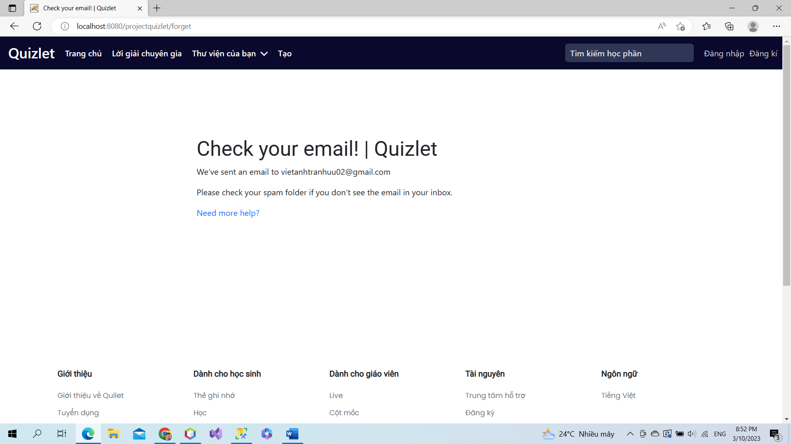

System remind user to check email to receive link to change password.

## 5. Change Password

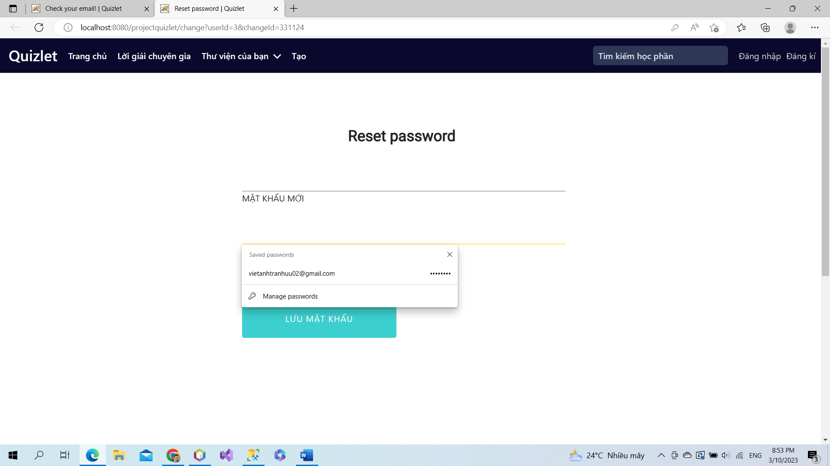

User input new password and confirm it to change password.

## 6. Verify account

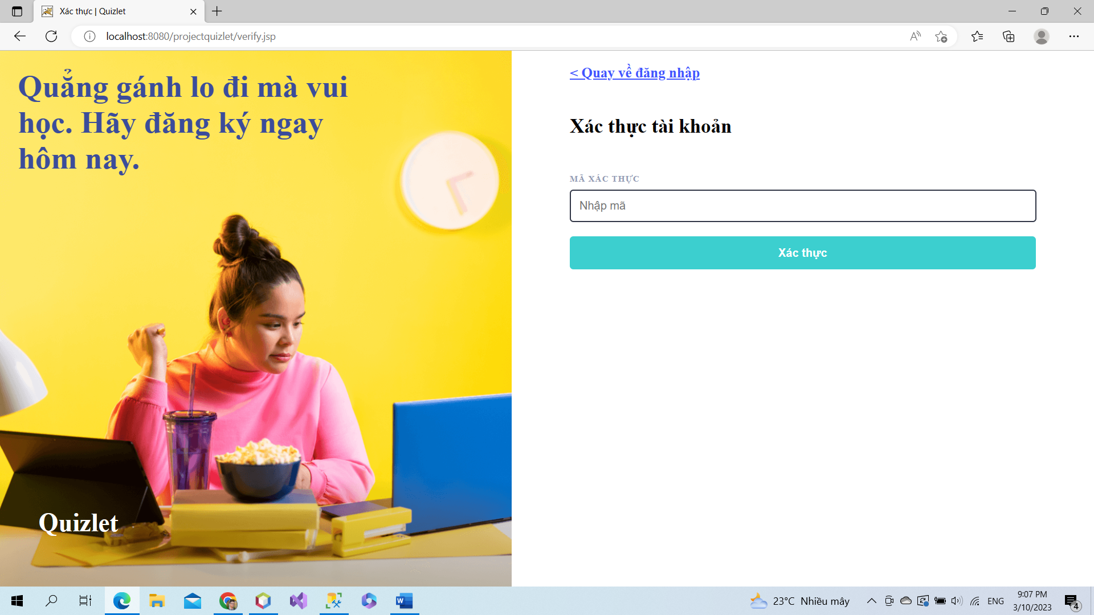

User input verified code in email to form to active account.

## 7. Logout

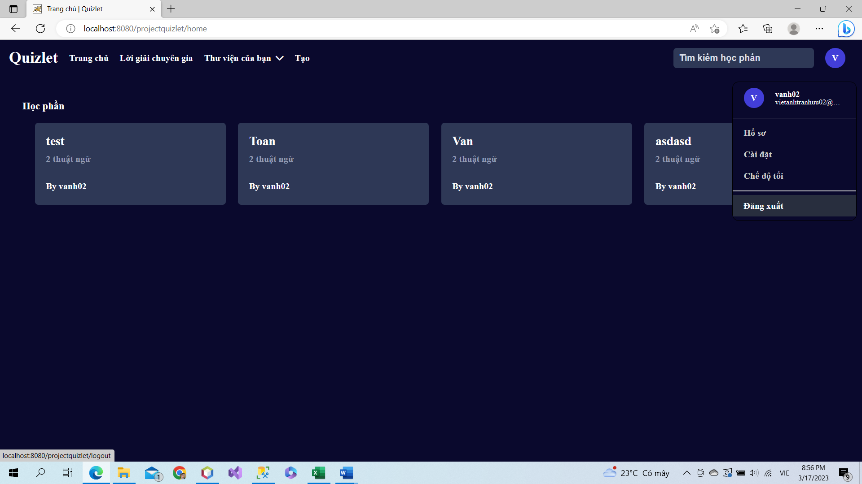

User click logout to leave page.

**C. After Login**

## 1. Home page

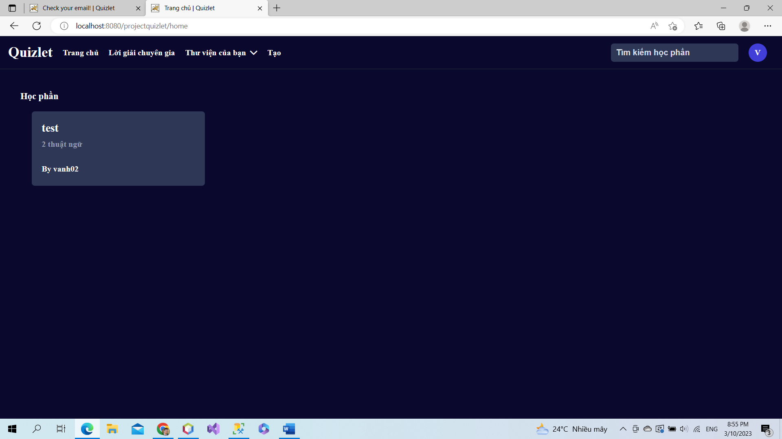

**This is home page after login**

## 2. Flash card

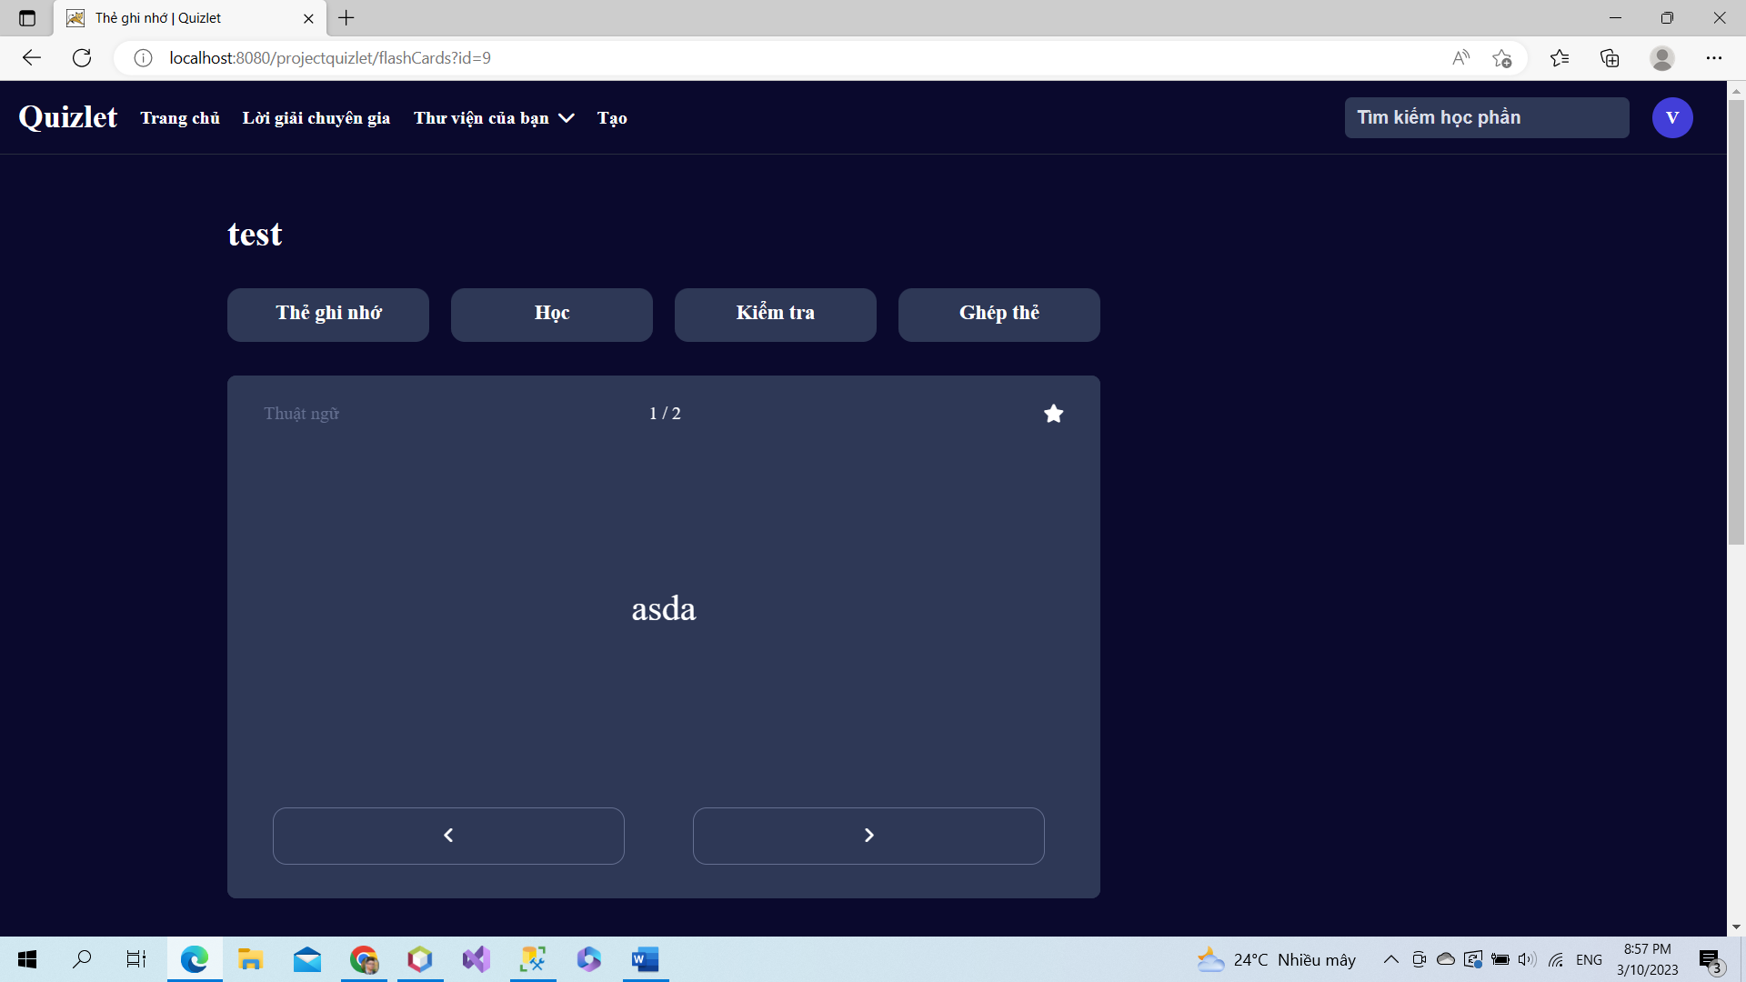

**After login user can view, edit, delete card, study sets**

## 3. Delete study set

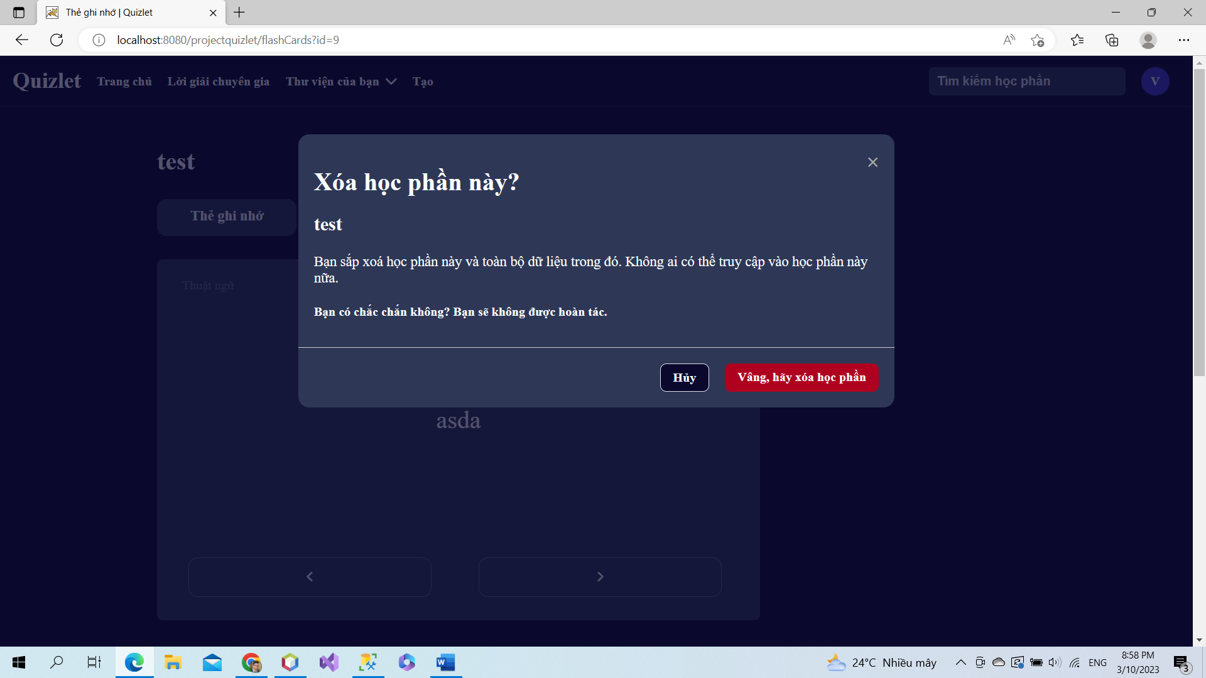

**Users can delete their study sets.**

## 4. Edit study sets

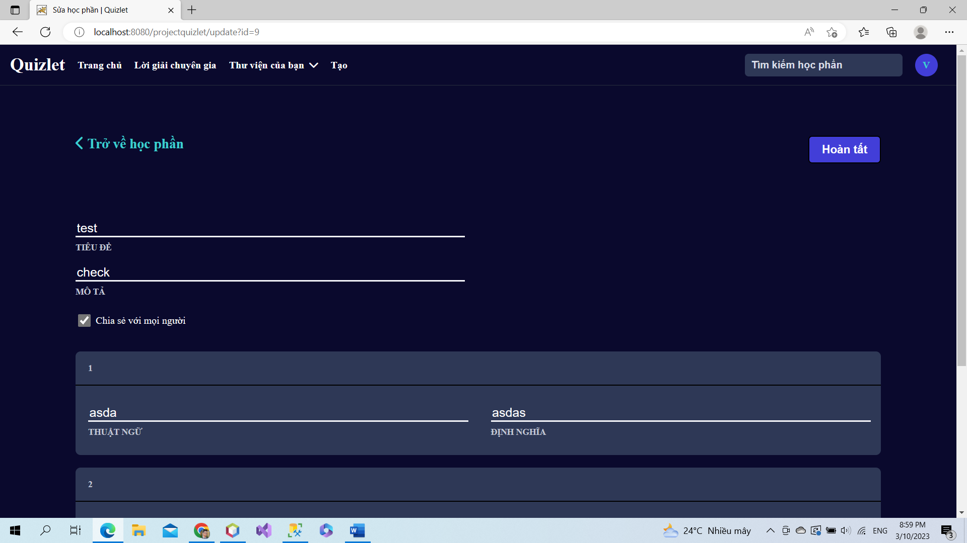

**Users can edit study sets, add more cards and change content in study sets. And users can share or not their study sets.**

## 5. Create study sets

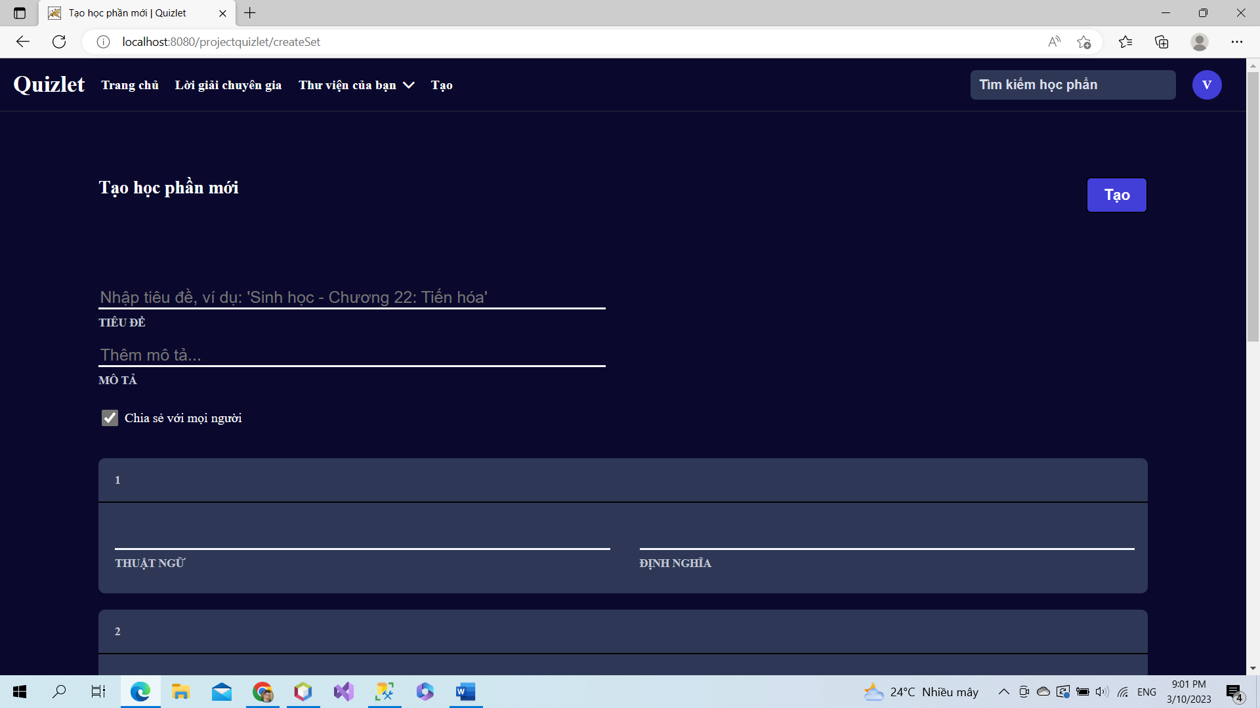

**Users can create a new study sets and cards in here.**

## 6. Create folder

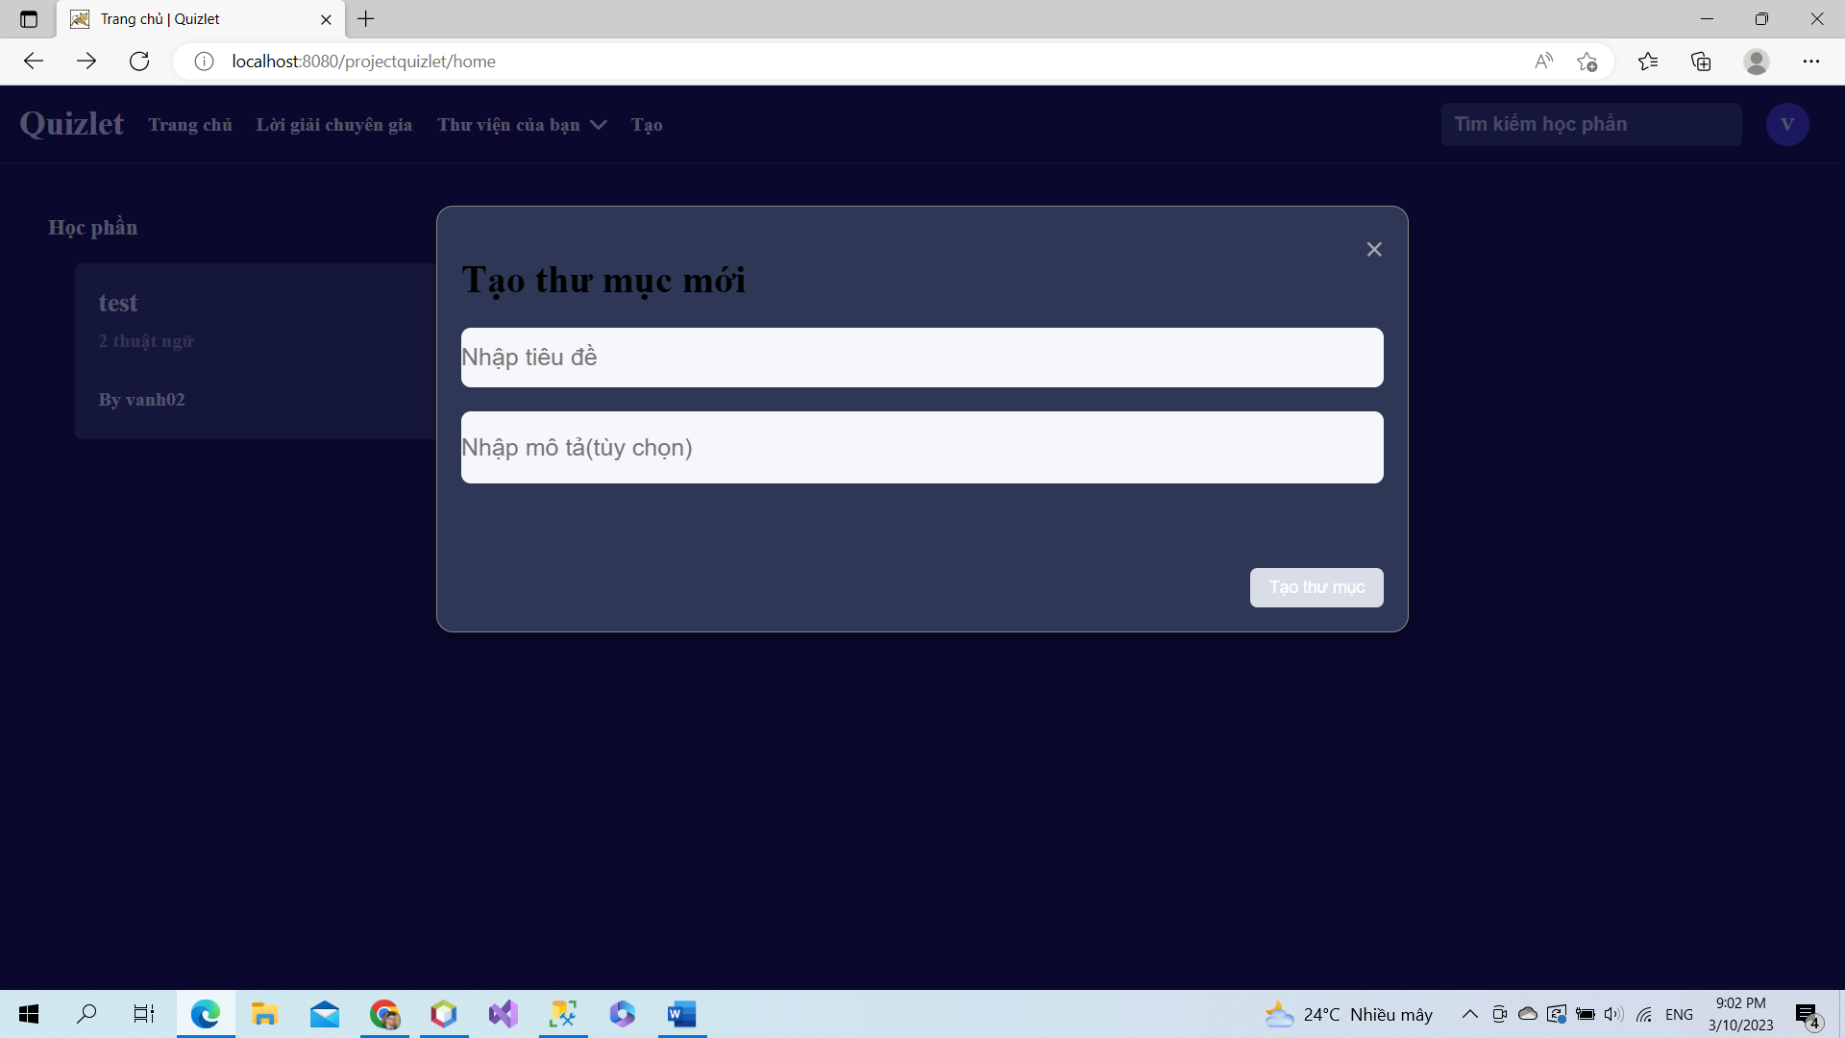

**Users can create a new folder.**

## 7. List folder

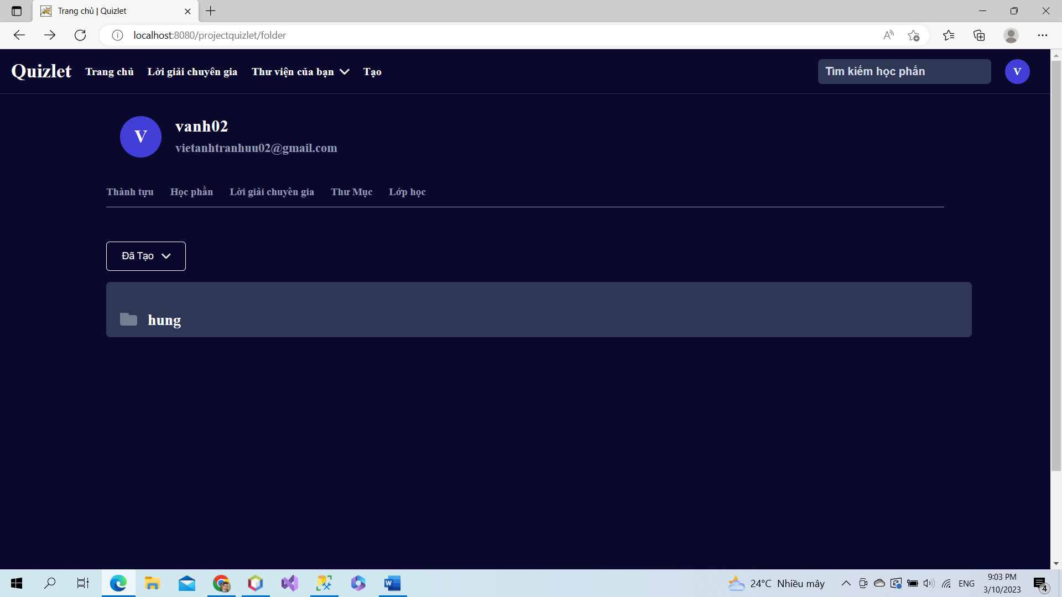

**List folders are created.**

## 8. View folder

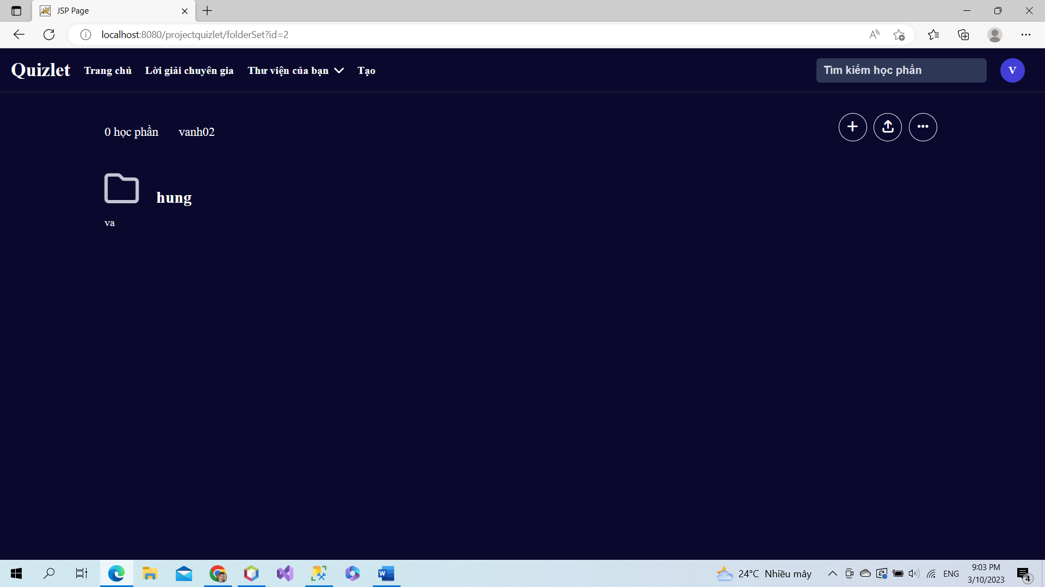

**View content of folder.**

## 9. CRUD study sets in folder

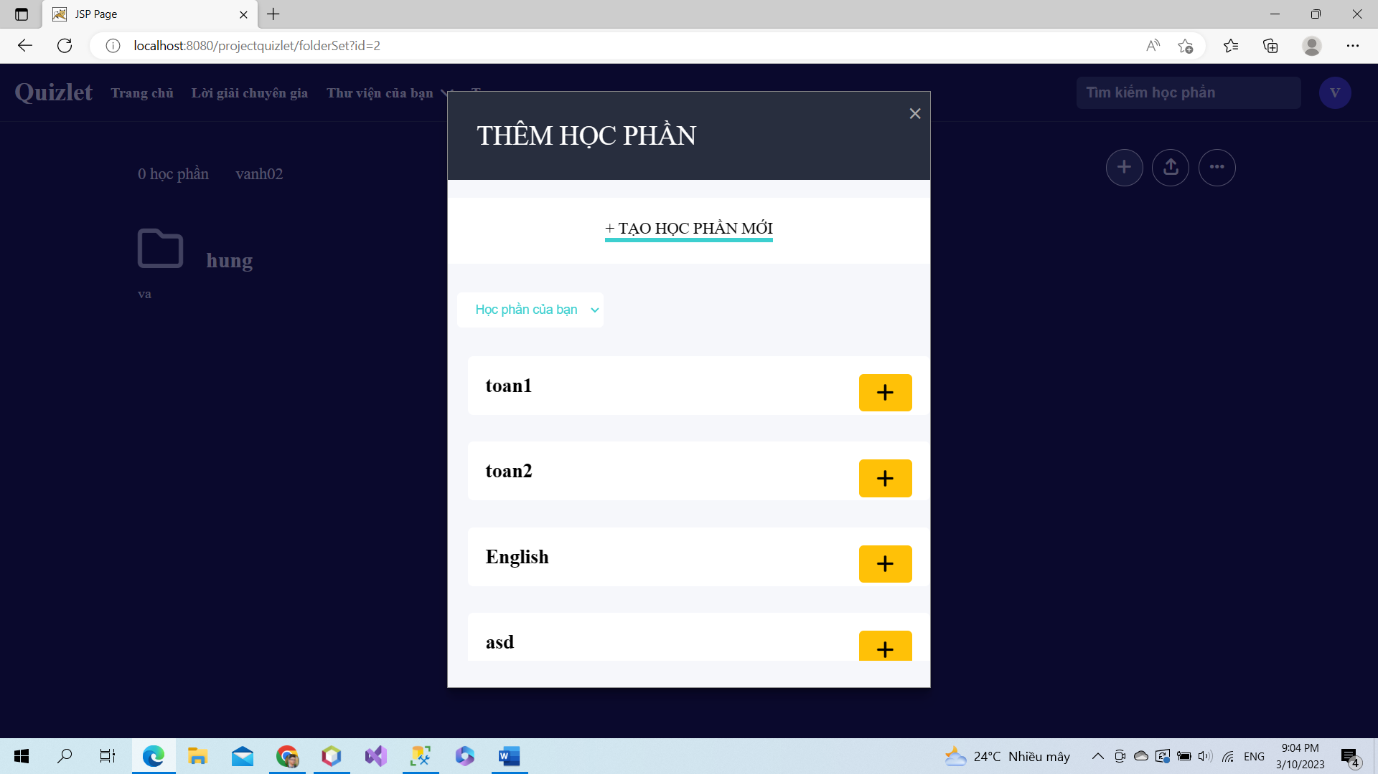

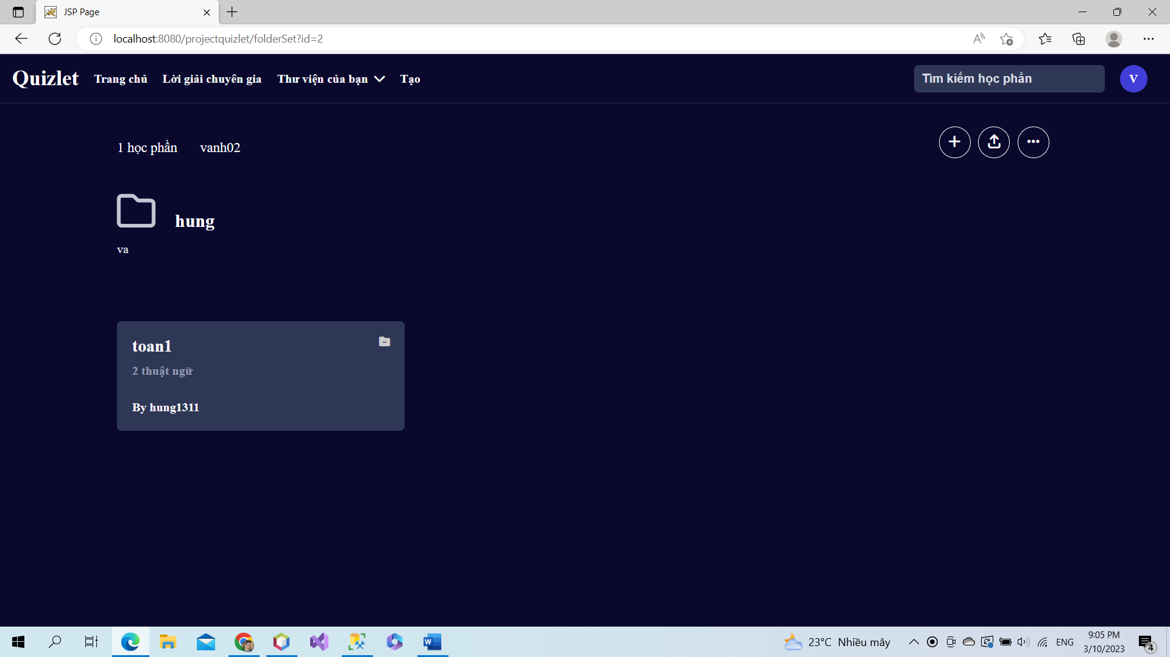

**Users can create, add, delete some study sets to folder.**

## 10. Create class

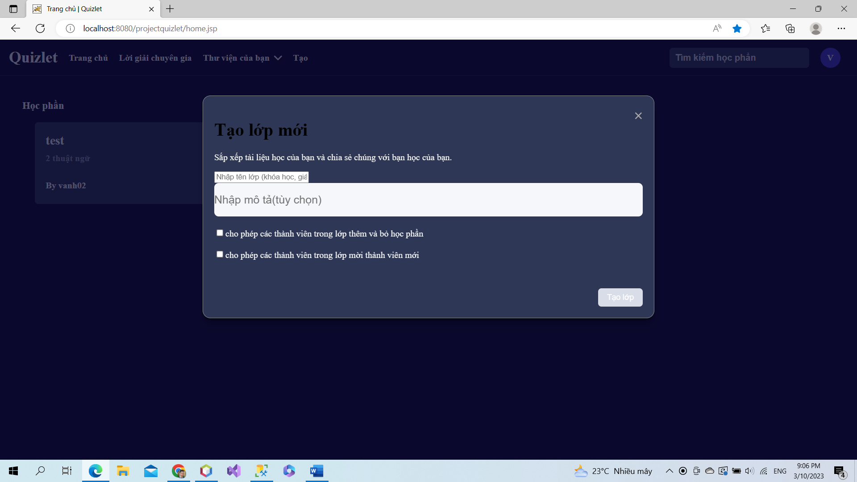

**Users can create a class.**

## 11. List class

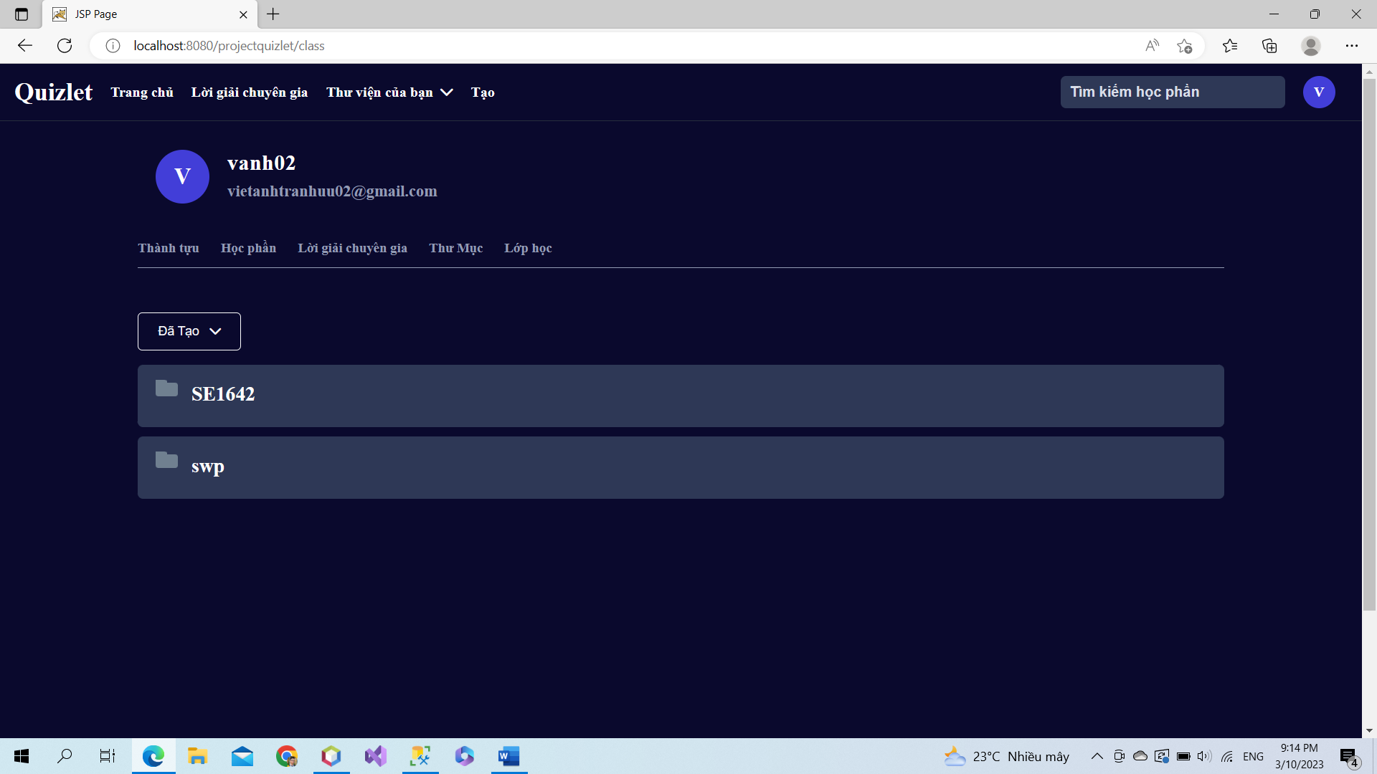

**Users can view list class which are created.**

## 12. Your library

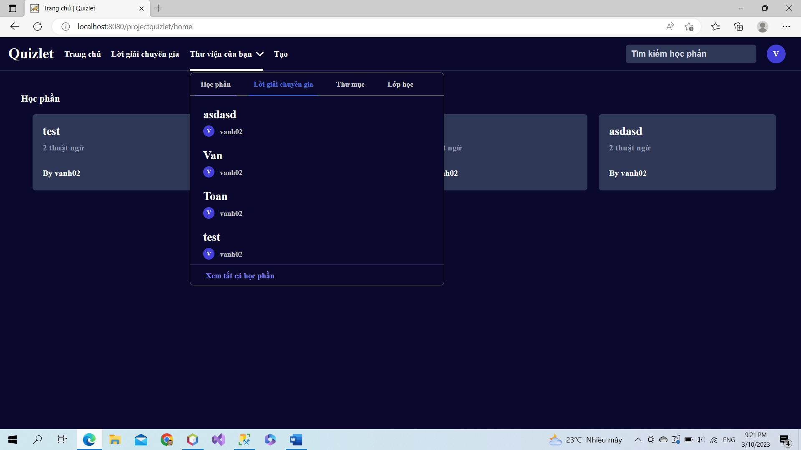

**Users can view study sets, answers of professors, folders and classes which are created**

## 13. CRUD class

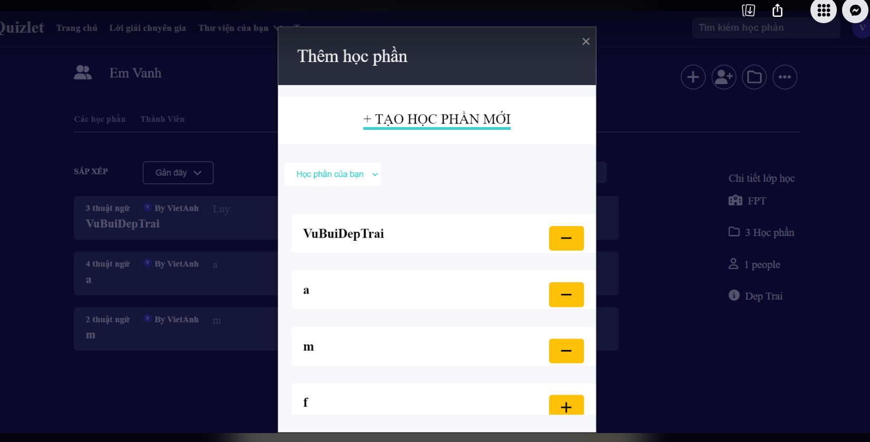

**Users can add, delete and create a new study sets in class.**